UNDERSTANDING COMMON LABORATORY TESTS
Patient & Clinician Educational Material
This document contains revised, patient-friendly descriptions of selected laboratory tests and panels. It is suitable as a content draft for a laboratory website

Advanced HBV, HCV & HIV Screening

Hepatitis B virus (HBV), hepatitis C virus (HCV), and human immunodeficiency virus (HIV) are important blood-borne infections. Laboratory testing can detect infection, support diagnosis, and—when appropriate—help monitor treatment.

What the test detects
Depending on the assay, testing may look for viral antigens, antibodies, or viral nucleic acid. Nucleic-acid amplification tests (NAAT/PCR) detect viral genetic material: HBV DNA and HCV/HIV RNA.

Why it may be requested
Testing may be used for screening, evaluation of suspected infection, confirmation of selected results, assessment before certain treatments or procedures, and monitoring of known infection.

Important interpretation point
A positive screening result does not always establish the stage or activity of infection. Follow-up testing and clinical assessment may be required. The timing of testing after exposure also matters because markers may not be detectable immediately.

Thyroid Function Tests (TFTs)

The thyroid is a small gland in the neck that produces hormones involved in metabolism, heart rate, temperature regulation and many other body functions.

Common tests
TSH (thyroid-stimulating hormone) is usually the starting test. Free T4 (FT4) and, in selected situations, free T3 (FT3) provide additional information about thyroid hormone production and activity.

Autoimmune testing
Thyroid antibody tests may be requested when an autoimmune thyroid disorder is suspected.

Monitoring
Thyroglobulin and calcitonin may be used in specific clinical situations, including follow-up of selected thyroid cancers; they are not routine thyroid-function tests.
TSH | FT4/FT3 | General pattern*
High | Low FT4 | Primary hypothyroidism
Low | High FT4 and/or FT3 | Hyperthyroidism
High | Normal FT4 | Possible subclinical hypothyroidism
Low | Normal FT4 | Possible subclinical hyperthyroidism
Important: *Interpretation depends on the clinical context, medications, pregnancy status, illness and laboratory reference intervals. Pituitary or hypothalamic disorders can produce different patterns.

Liver Function Tests (LFTs)
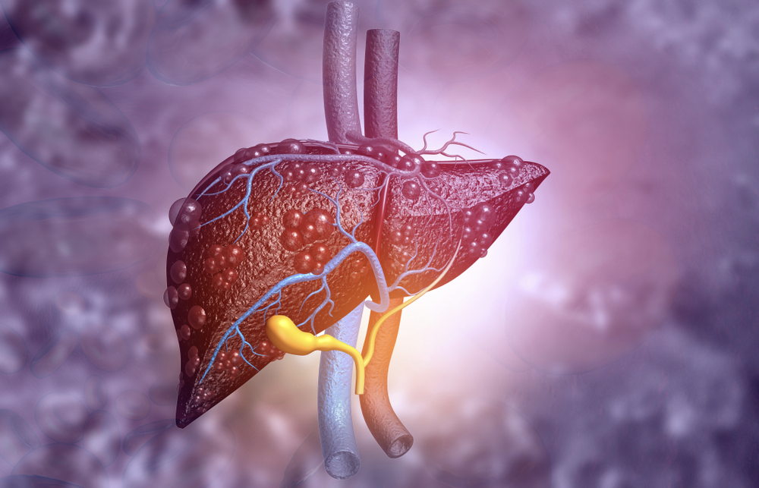
Liver function testing is a group of blood tests that evaluates enzymes, proteins and other substances associated with liver and biliary-tract health. The results are interpreted together rather than as isolated numbers.
Test | What it can indicate
ALT | An enzyme found mainly in liver cells. Increased levels commonly indicate hepatocellular injury, although ALT can also be affected by other conditions.
AST | An enzyme found in the liver and other tissues, including muscle and heart. It can rise with liver or non-liver tissue injury.
ALP | An enzyme associated mainly with the liver/bile ducts and bones. An increased result may arise from either source.
GGT | An enzyme associated with the liver and bile ducts. It can help interpret an elevated ALP and may also rise with alcohol exposure or some medicines.
Bilirubin | A breakdown product of haemoglobin that is processed and excreted by the liver. Increased bilirubin may contribute to jaundice.
Albumin | A major blood protein made by the liver. Persistently low albumin can occur in chronic liver disease, but it is not specific to the liver.
Total protein | Measures albumin plus other blood proteins, including antibodies.
Prothrombin time (PT/INR) | Assesses blood clotting. Because several clotting factors are made in the liver, prolonged PT/INR can occur with impaired liver synthetic function, although there are other causes.
Important: LFTs do not by themselves diagnose a particular liver disease. Results should be considered alongside symptoms, examination, medical history and, when indicated, imaging or additional laboratory tests.

Kidney Function Tests (KFTs)
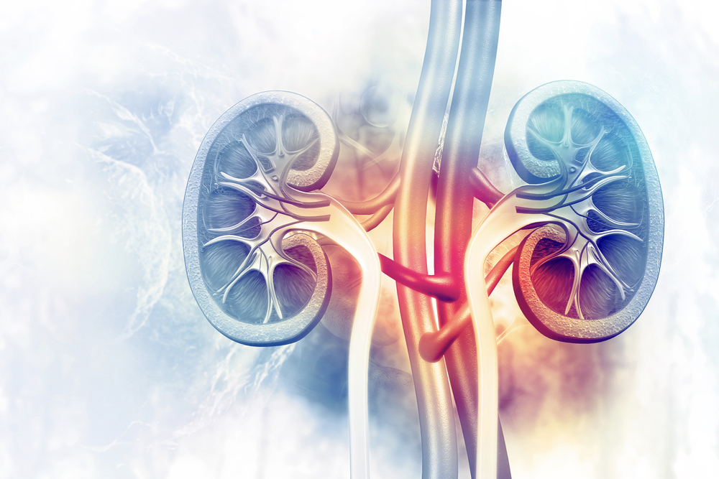
Kidney function tests assess how well the kidneys filter blood, regulate fluid and electrolytes, and maintain the body's chemical balance. They can help detect and monitor kidney problems but usually do not identify the cause on their own.
Test/component | What it assesses
Creatinine | A waste product produced by muscle metabolism and normally cleared by the kidneys. Blood creatinine is commonly used to estimate kidney filtration.
Urea | A nitrogen-containing waste product formed during protein metabolism and excreted by the kidneys. It can be affected by hydration, diet and other factors.
eGFR | An estimate of glomerular filtration based mainly on creatinine and demographic/clinical variables. It is used to assess kidney filtration and stage chronic kidney disease when appropriate.
Electrolytes | Sodium, potassium, chloride and bicarbonate help regulate fluid balance, nerve and muscle function, and acid-base status.
Calcium & phosphate | Important for bone health, muscle and nerve function, energy metabolism and acid-base balance.
Cystatin C | An alternative filtration marker that can be useful in selected patients and may improve estimation of kidney function when creatinine is less reliable.
Glucose | Measured when assessment of glucose metabolism or diabetes is relevant to kidney health.
Albumin | A major blood protein. Blood albumin may be included as part of a broader assessment, while urine albumin is commonly used to assess kidney damage.

Full Blood Count (FBC)
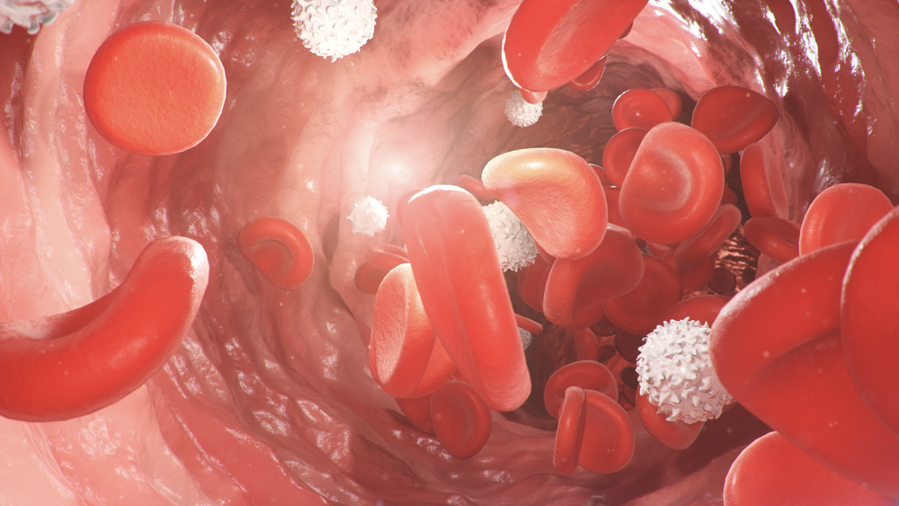
A full blood count (FBC), also called a complete blood count (CBC), measures the major cell types in blood. It is widely used to assess general health and investigate conditions affecting red cells, white cells and platelets.
Parameter | What it tells us
Red blood cell (RBC) count | The number of red blood cells, which carry oxygen around the body.
Haemoglobin (Hb) | The oxygen-carrying protein in red blood cells. A low level is a common feature of anaemia.
Haematocrit (Hct) | The proportion of blood made up of red blood cells.
MCV | Average red-cell size. Low MCV is commonly associated with iron deficiency or thalassaemia; high MCV has several possible causes, including vitamin deficiency and some liver or thyroid disorders.
MCH / MCHC | Measures related to the amount and concentration of haemoglobin in red blood cells.
RDW | Describes variation in red-cell size and can help classify some anaemias.
Reticulocyte count | Measures immature red blood cells and helps assess whether the bone marrow is responding appropriately to anaemia or blood loss.
White blood cell count & differential | Assesses immune cells and can provide clues about infection, inflammation, immune disorders and some blood cancers.
Platelet count / MPV | Platelets are important for clot formation. Platelet count and size can provide information about bleeding/clotting disorders and platelet production.
Important: An abnormal FBC is not a diagnosis by itself. Interpretation depends on the pattern of results, symptoms, age, pregnancy status, medicines and the laboratory's reference intervals.

Tumour Markers

Tumour markers are substances that may be produced by cancer cells or by the body in response to cancer. They are measured in blood, urine or other specimens in selected clinical situations.

What tumour markers can do
Depending on the marker and cancer type, testing may support evaluation of symptoms, help with staging or prognosis, guide selected treatment decisions, monitor response to treatment, or help detect recurrence.

What tumour markers cannot do
Most tumour markers are not sufficiently specific or sensitive to diagnose cancer on their own, and many are not suitable for general population screening. Benign conditions can also increase tumour-marker levels.
Marker | Common clinical associations | Typical use*
CA 15-3 | Breast cancer; may also rise in some other cancers and benign conditions | Selected monitoring and recurrence assessment
CA 19-9 | Pancreatic and biliary cancers; may rise in benign biliary/pancreatic disease | Selected monitoring and response assessment
CA-125 | Ovarian and other gynaecologic malignancies; may rise in benign conditions such as endometriosis | Selected evaluation and monitoring
CEA | Colorectal and several other cancers; may also rise in benign disease and in smokers | Monitoring selected cancers and recurrence
β-hCG | Pregnancy and selected germ-cell/trophoblastic tumours | Diagnosis/supportive evaluation and monitoring in appropriate settings
PSA | Prostate tissue; increased with prostate cancer and also with benign prostatic enlargement or inflammation | Risk assessment, diagnosis support and monitoring; screening decisions are individualized
Important: *Use is cancer- and patient-specific. A tumour-marker result should never be interpreted in isolation.

Lipid Profile
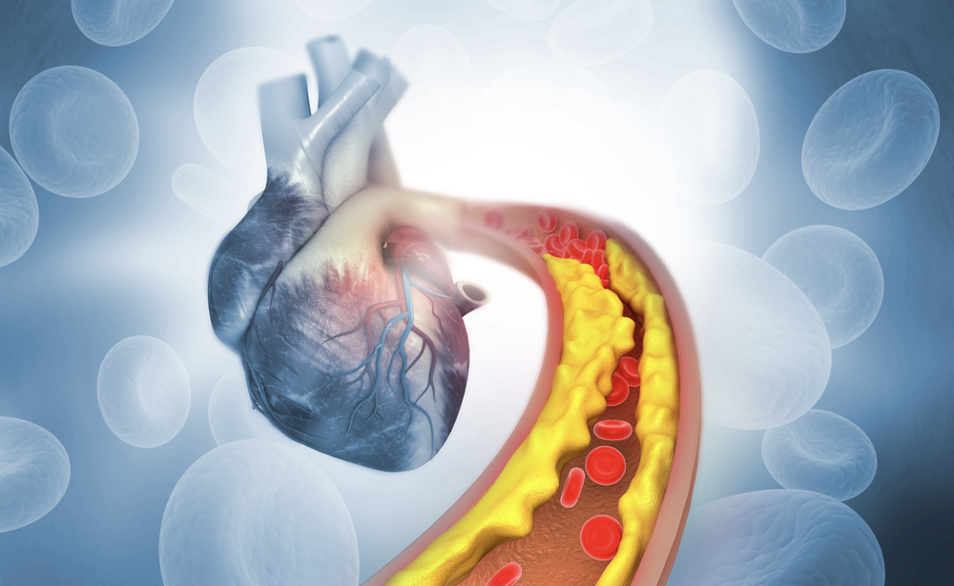
A lipid profile measures blood fats and cholesterol to help assess cardiovascular risk. Results are interpreted together with other risk factors such as age, blood pressure, diabetes, smoking history and family history.
Component | Meaning
Total cholesterol | The total amount of cholesterol carried by lipoproteins in the blood.
LDL cholesterol | Often called 'bad' cholesterol. Higher levels are associated with atherosclerotic cardiovascular disease risk.
HDL cholesterol | Often called 'good' cholesterol because HDL participates in reverse cholesterol transport. HDL is interpreted as part of the overall risk profile rather than as a stand-alone protective target.
Non-HDL cholesterol | Total cholesterol minus HDL cholesterol; represents cholesterol carried by all non-HDL lipoproteins.
Triglycerides | A major form of circulating fat. High levels can contribute to cardiovascular risk and, when markedly elevated, increase pancreatitis risk.
Total cholesterol / HDL ratio | A calculated measure sometimes used as part of cardiovascular risk assessment.
Important: A lipid profile may be performed fasting or non-fasting depending on the clinical question and laboratory protocol. Treatment targets are individualized.

HbA1c (Glycated Haemoglobin)
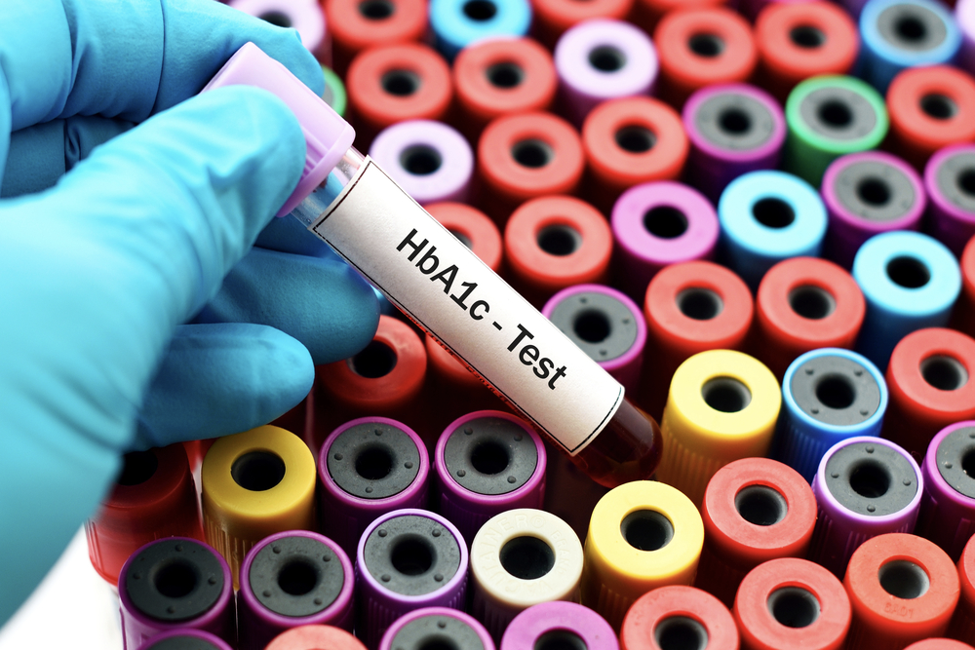
HbA1c measures the proportion of haemoglobin that has glucose attached to it. It reflects average blood-glucose exposure over approximately the previous 2–3 months and is widely used to assess glycaemic control and, in appropriate people, to diagnose diabetes.
HbA1c (non-pregnant adults) | General interpretation
Below 5.7% (below 39 mmol/mol) | Usually considered in the normal range
5.7–6.4% (39–47 mmol/mol) | Prediabetes / increased risk of diabetes
≥6.5% (≥48 mmol/mol) | Meets the laboratory diagnostic threshold for diabetes; confirmation is generally required when there is no unequivocal hyperglycaemia
Important: HbA1c can be affected by conditions that change red-cell lifespan or haemoglobin structure, including some anaemias and haemoglobin variants. Diagnostic thresholds and interpretation should follow current clinical guidance and the laboratory's validated method.

TORCH / Congenital Infection Testing

TORCH is a traditional term used for infections that can cause congenital or neonatal disease. The acronym is commonly expanded as Toxoplasma, Other infections, Rubella, Cytomegalovirus (CMV) and Herpes simplex virus (HSV). The exact tests included vary by laboratory and clinical indication.

Toxoplasmosis
Toxoplasma gondii infection can be acquired through contaminated food or soil and can cross the placenta during pregnancy. Congenital infection can affect the eyes and central nervous system.

Rubella
Rubella infection during pregnancy can cause congenital rubella syndrome, with risks including hearing, eye and heart abnormalities and other developmental problems. Vaccination is the main prevention strategy.

Cytomegalovirus (CMV)
CMV is common and often mild in healthy adults, but primary or recurrent infection during pregnancy can lead to congenital infection. Some affected infants develop hearing, neurological or developmental problems.

Herpes simplex virus (HSV)
Neonatal HSV can be acquired around delivery, particularly when genital infection is active. Newborn infection can be severe and requires prompt specialist management.

Other infections
The 'O' may include infections such as syphilis, varicella-zoster virus or parvovirus B19 depending on local practice and clinical need.
Important: Serology can indicate previous exposure or immune response and does not always prove an active infection. Interpretation in pregnancy often requires confirmatory or molecular testing and specialist clinical assessment.

HIV Viral Load
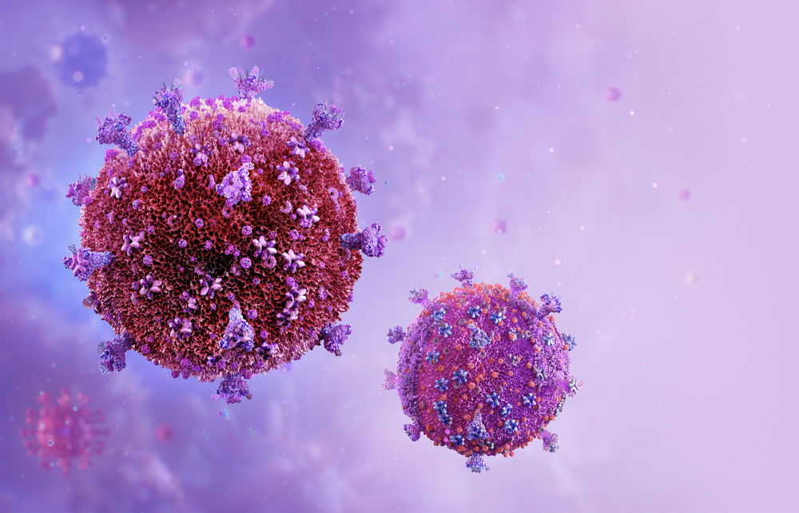
HIV viral-load testing measures the amount of HIV genetic material in a blood sample. It is primarily used after HIV has been diagnosed to assess how actively the virus is replicating and to monitor response to antiretroviral therapy.

Why it matters
A falling viral load after treatment generally indicates that therapy is suppressing HIV replication. Persistent or rising viral load may prompt assessment of adherence, drug interactions, resistance or other clinical factors.

How it is used
Testing is repeated at intervals recommended by the treating clinical team. It is commonly considered alongside CD4 cell count and the overall clinical picture.
Important: Viral-load results are assay-specific and are usually reported as copies of HIV RNA per millilitre of blood, sometimes with a statement that the result is below the assay's limit of detection or quantification.

Cardiac Biomarkers

Cardiac biomarkers are substances measured in blood to help evaluate heart-muscle injury or cardiac stress. They are interpreted alongside symptoms, examination, ECG findings and other investigations.
Marker | What it indicates | Typical clinical role
Cardiac troponin I or T | Proteins released when heart muscle cells are injured | Preferred biomarker for suspected acute myocardial injury/heart attack
BNP / NT-proBNP | Peptides released when the heart is under increased wall stress | Support diagnosis and monitoring of heart failure
CK-MB | An enzyme associated with muscle injury, including heart muscle | Used less often than troponin; may have a role in selected situations
Important: Troponin can rise in conditions other than heart attack, including myocarditis, severe illness and kidney disease. The timing of symptoms and serial measurements are important when assessing acute chest pain.

Sexual Health & STI Testing
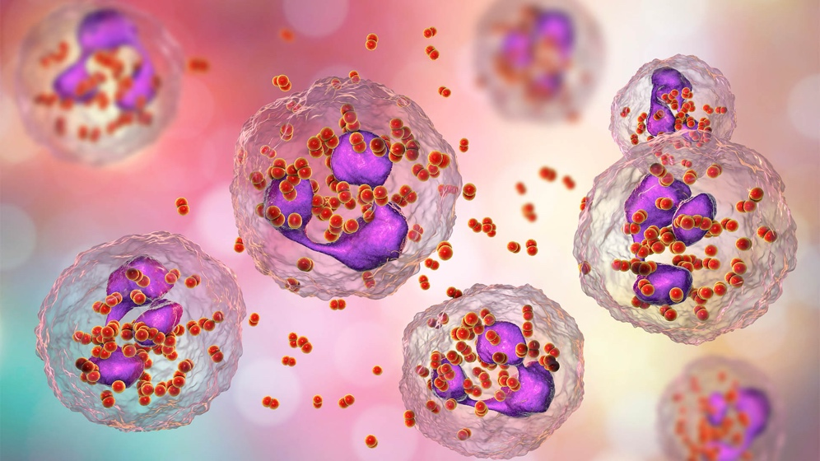
Sexually transmitted infections (STIs) can be passed through vaginal, anal or oral sex and through intimate skin-to-skin contact. Many infections cause few or no symptoms, so testing may be appropriate based on symptoms, exposure, sexual history, pregnancy, screening recommendations or partner notification.

Possible targets
Depending on the laboratory assay and clinical indication, molecular testing may target organisms such as Chlamydia trachomatis, Neisseria gonorrhoeae, Mycoplasma genitalium, Trichomonas vaginalis and Treponema pallidum, as well as selected viral targets such as HSV-1/HSV-2.

Important assay note
Some organisms included in commercial multiplex panels—such as Candida species, Gardnerella vaginalis, Ureaplasma species or Mycoplasma hominis—may represent colonization or conditions that require clinical correlation rather than automatic treatment. A positive molecular result does not always mean that treatment is indicated.

Why testing matters
Early diagnosis can reduce complications and transmission. Treatment depends on the organism, symptoms, pregnancy status, site of infection and current clinical guidance.
Important: Specimen type matters. Depending on the suspected infection, testing may use urine, vaginal/cervical, urethral, rectal, pharyngeal, lesion or blood specimens.

Cervical Screening & HPV Genotyping

Human papillomavirus (HPV) is a very common infection. Persistent infection with certain high-risk HPV types can cause cellular changes that may progress to cervical cancer. HPV testing is therefore an important component of cervical-cancer prevention.

What the test detects
HPV genotyping assays detect DNA from selected HPV types in cervical specimens. The exact types reported depend on the validated assay used by the laboratory.

High-risk HPV
High-risk types include HPV 16 and 18 and several other oncogenic types. A positive high-risk HPV result does not mean that cancer is present; it identifies an infection that may require risk-based follow-up.

Low-risk HPV
Types such as HPV 6 and 11 are commonly associated with genital warts and are not considered major causes of cervical cancer.

Why screening matters
Cervical screening can identify HPV infection or precancerous cellular changes early, allowing appropriate surveillance or treatment before invasive cancer develops.
Important: Follow-up after a positive HPV result depends on the person's age, screening history, HPV type, cytology result and local screening programme. Laboratory results should be interpreted using the applicable national guideline.

